NAME : AAYSHA BEGAM ABUBAKAR SIDDIK

EMP ID:761155

LOCATION:CHENNAI

SCHEMA DIAGRAM OF DATABASE:

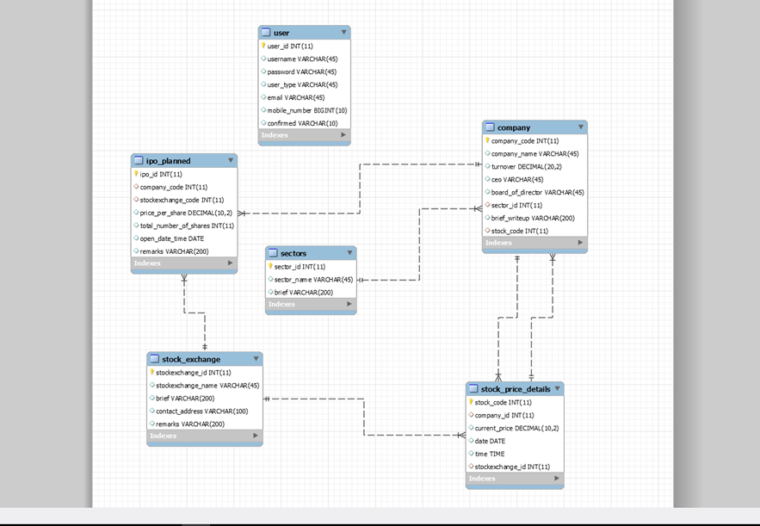

OUTPUT PAGE

COMPANY LIST BY IPO ID

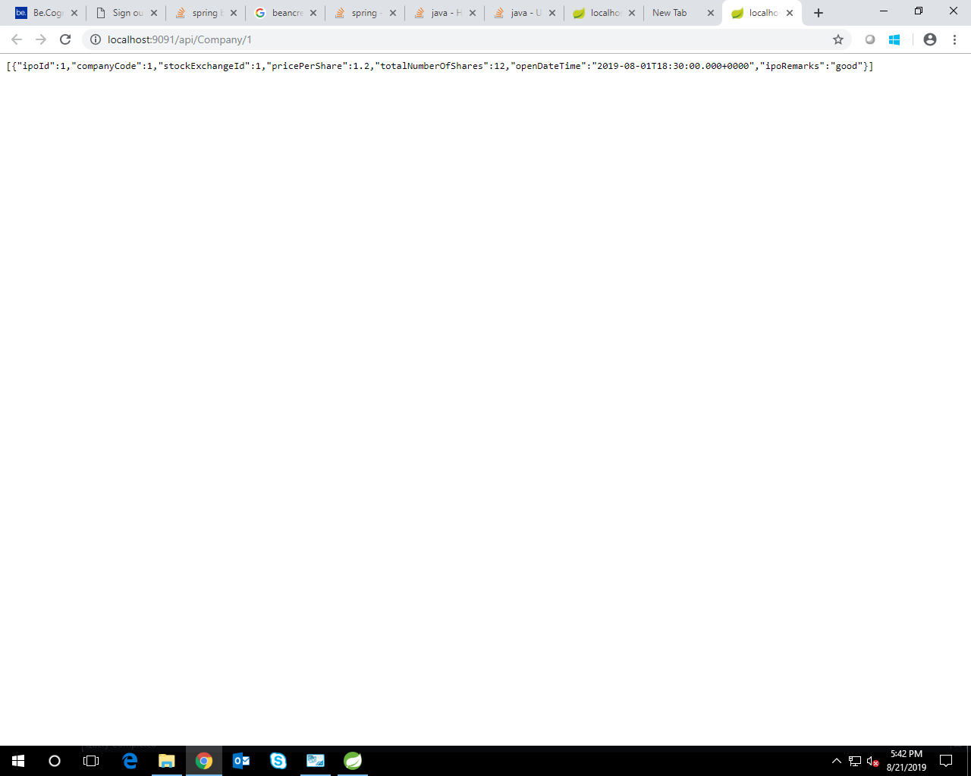

COMPANY LIST BY SECTOR ID

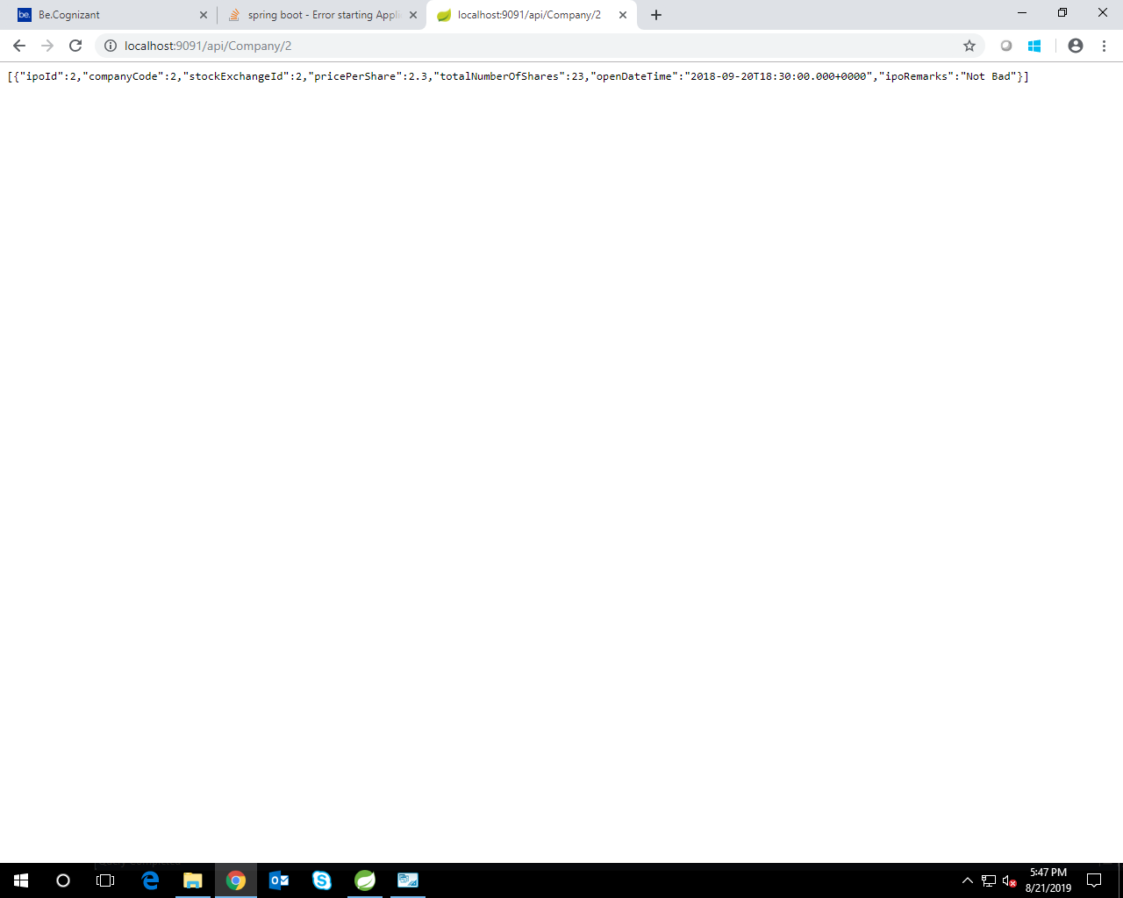

HTML PAGES

SIGN IN /SIGN UP HTML PAGE



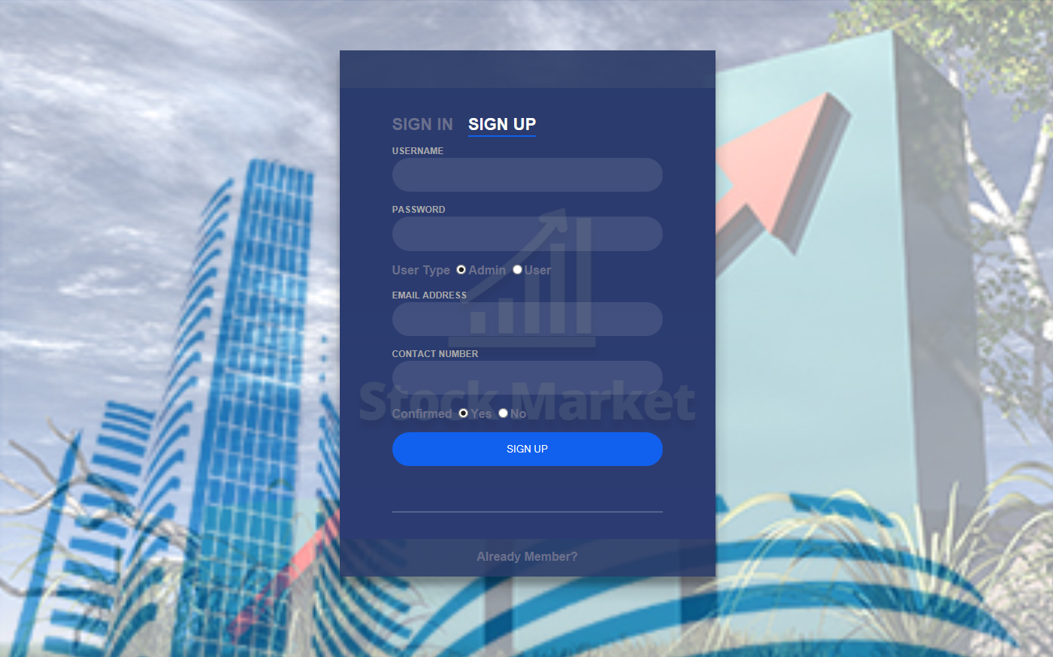

ADMIN HOME PAGE



IMPORT DATA PAGE

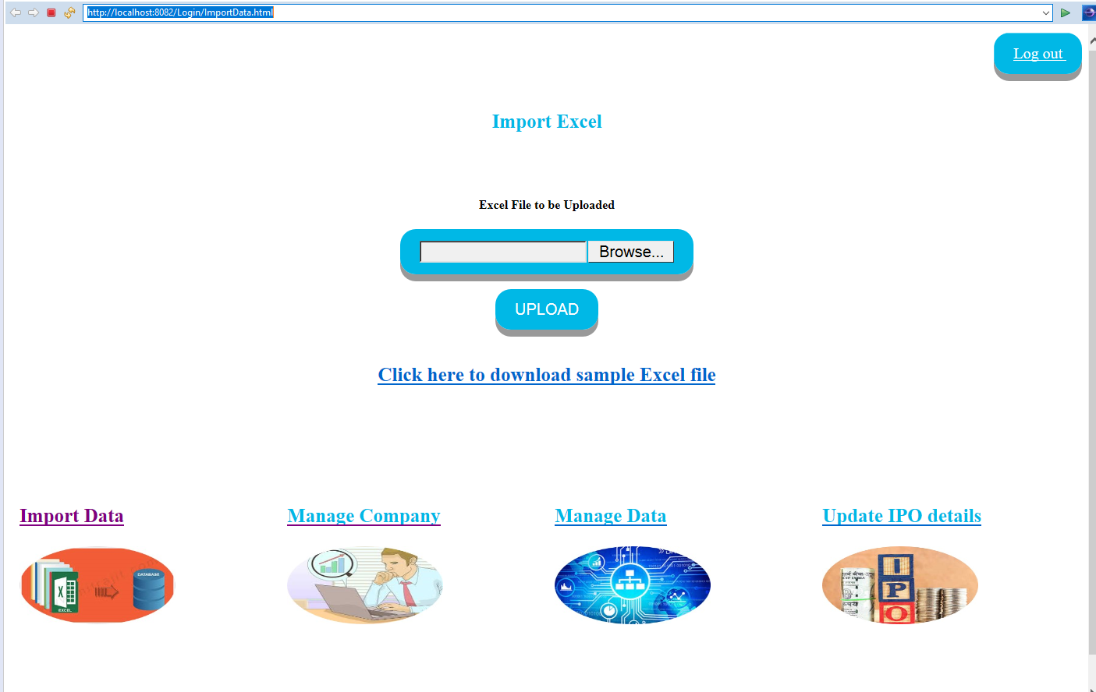

UPLOAD PAGE

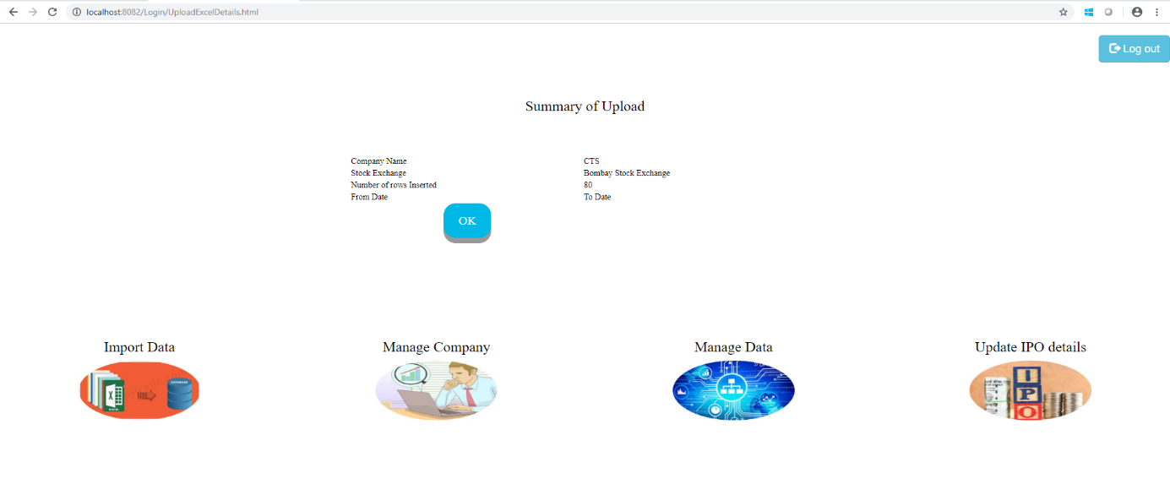

UPLOAD SUCCESS PAGE

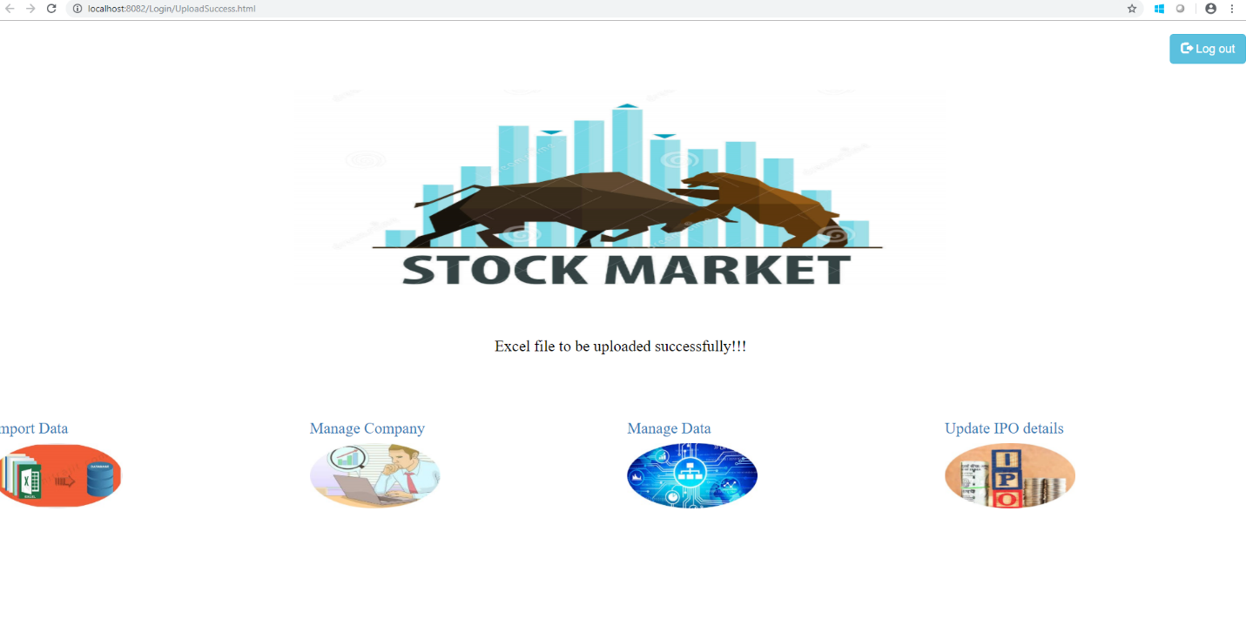

MANAGE COMPANY PAGE

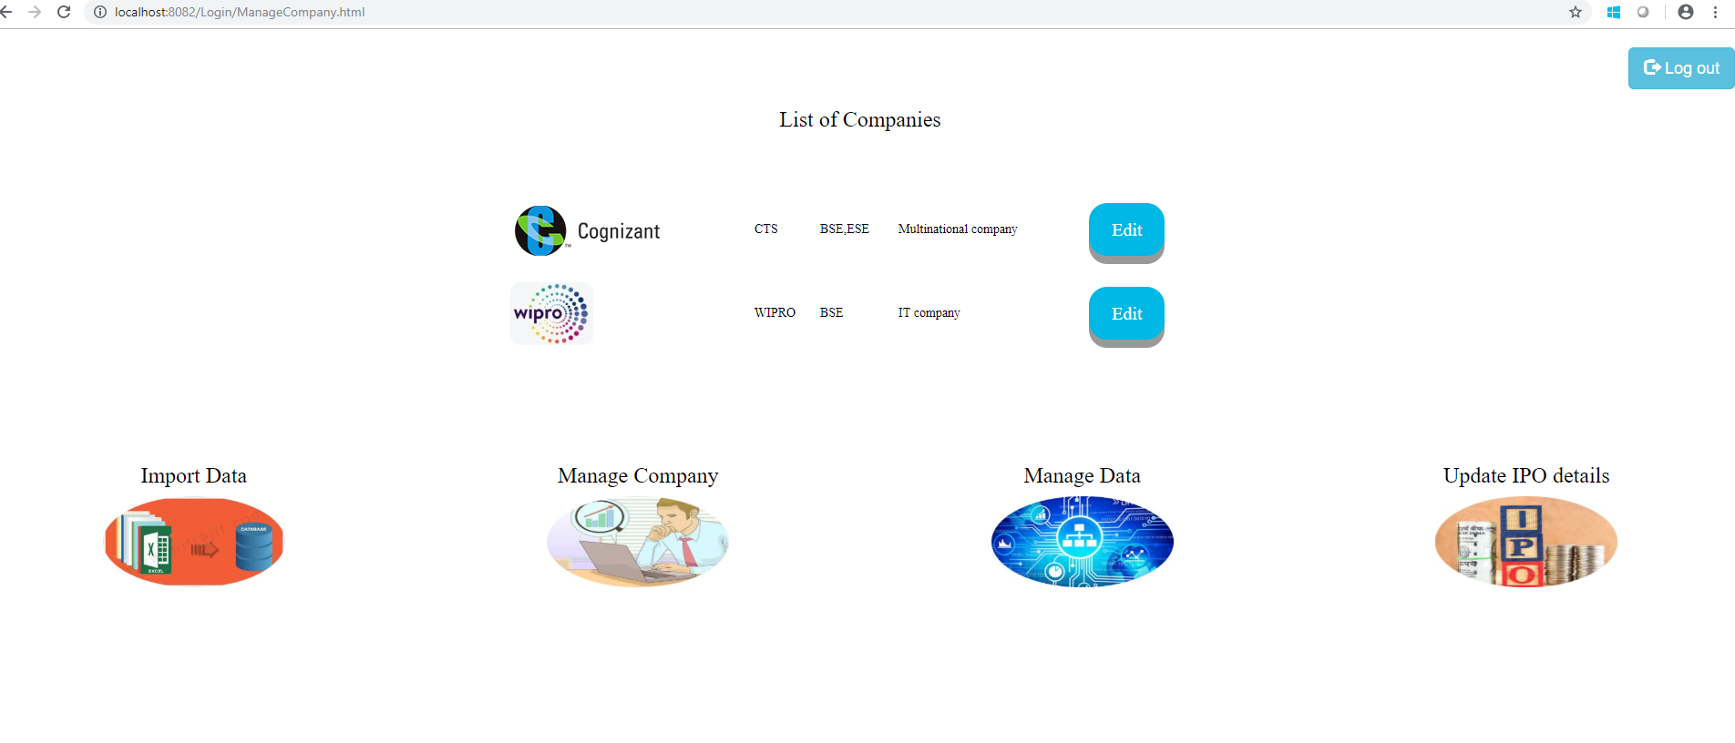

USER HOME PAGE



CREATE NEW COMPANY

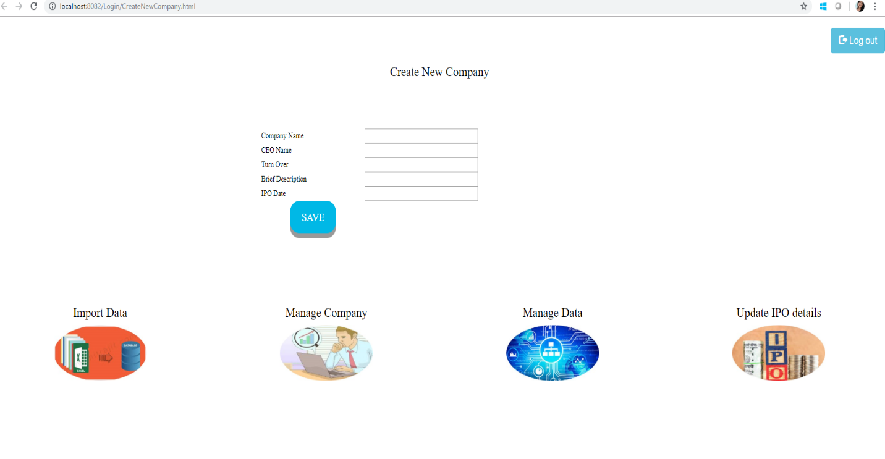GIT HUB LINK :

https://github.com/AayshaBegamAbubakar/stock_market